**Annual General Meeting**

**Launceston Volunteers For Community**

2021 - 2022



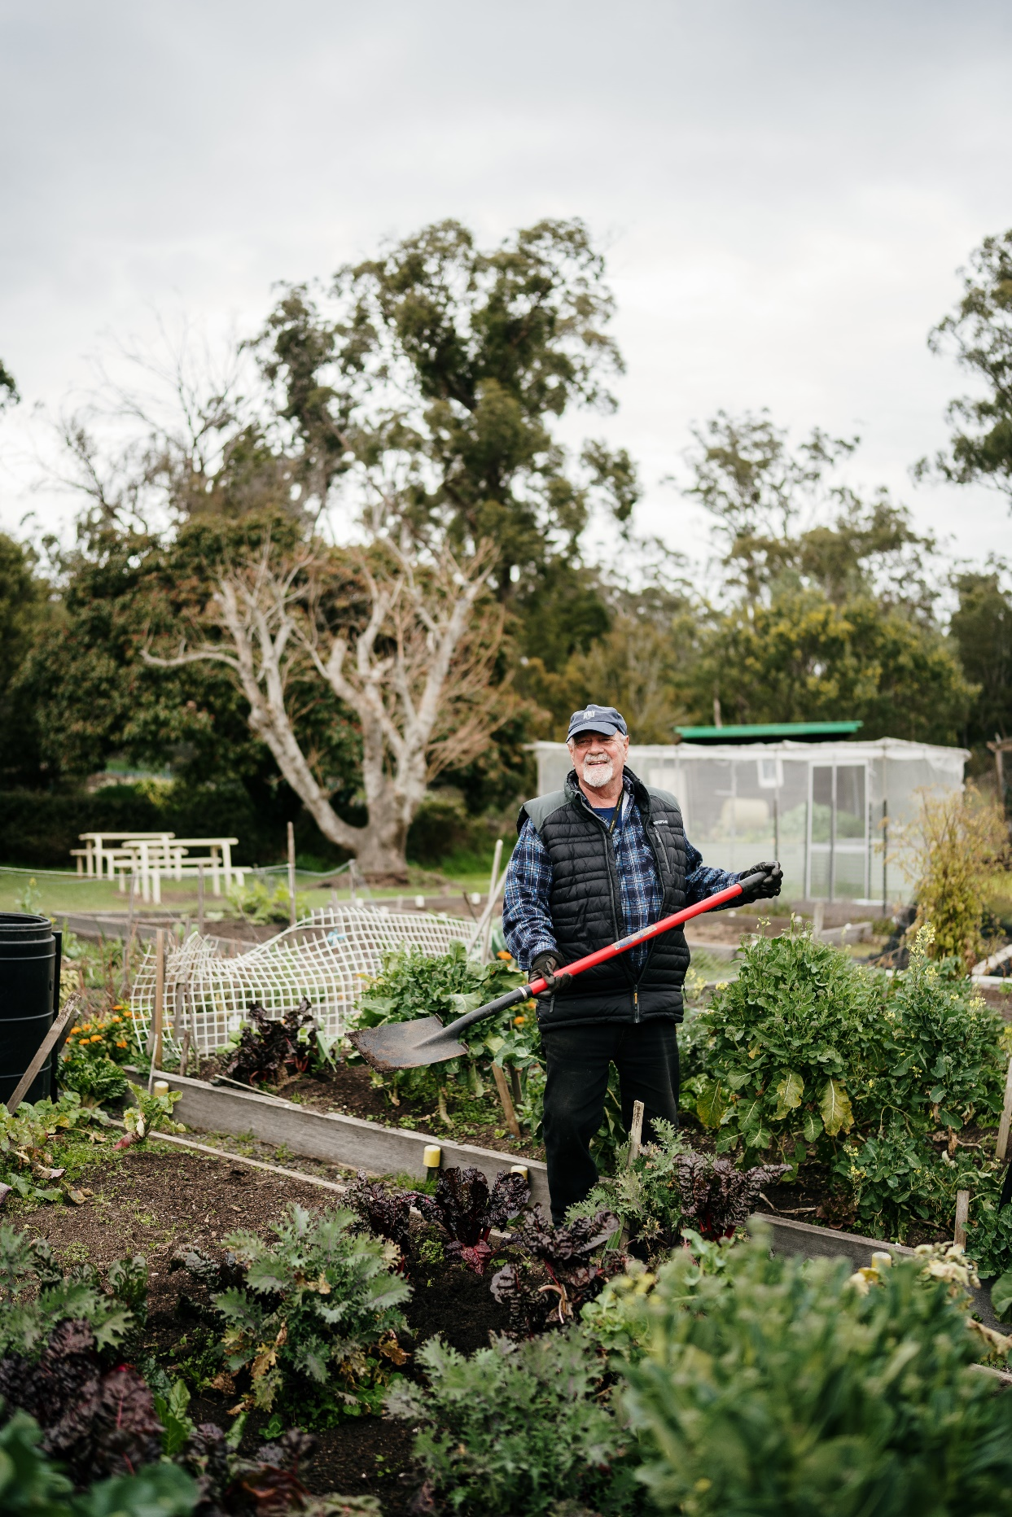

CONTENTS

Introduction

AGM Notification

Agenda

Previous Minutes

Reports

Presidents Report

General Manager

Treasurers - Audited Reports

**Amended Rules of the Association**

**Board Nominations received for 2022**

# INTRODUCTION

Launceston VFC Services exists to ensure people remain active members of the community. We create meaning and fulfillment in the lives of all our participants. Delivering high quality, meaningful interactions to promote independence to our clients and fulfillment to our volunteers. This is to create a thriving and connected community. Independent intake processes allow for individualized program activities, along with advice on remaining independent through the use of supports.

## **Vision**

To establish an enduring organization across Tasmania, providing services through volunteers, with the frail, the elderly, people living with a disability, the disadvantaged and the vulnerable.

## **Mission**

Our Mission is to provide a community led range of services, provided by volunteers, which respond to the needs of the frail, the elderly, people living with a disability, the disadvantaged and the vulnerable and empower them to lead more independent lives.

**LAUNCESTON VFC SERVICES INC NOTICE OF 2022 ANNUAL GENERAL MEETING**

To be held at Launceston VFC Offices at **56 Cimitiere Street Launceston on Tuesday 20th September, 2022 at 10am.**

Board nomination forms are available by calling 6336 5147 and should be directed to the Public Officer at Launceston VFC Services Inc 56 Cimitiere Street Launceston (PO Box 3052 Launceston 7250).

Nominations **close at 5pm on Monday 5th September 2022.**

Carolyn Campbell-Wood

Public Officer

(Copy of notice of advertisement as published in The Examiner on the 30th of August 2022)



|  |
| --- |
| ANNUAL GENERAL MEETING FOR LAUNCESTON VFC SERVICES INC  AGENDA |
| To be held at Launceston VFC Offices at 56 Cimitiere Street, Launceston |
| On Tuesday 20th September 2022 at 10am. |

1. Meeting open
   1. Welcome by President
   2. Rules and procedures of the meetings
   3. Apologies
2. Previous Minutes

2.1 Minutes of Annual General Meeting 2021

1. Reports
   1. President
   2. General Manager
   3. Treasurer – audited reports 2021-2022

1. Special Resolution on amendments to the Launceston VFC Services Inc Rules of Association.
   1. President – Resolution on amendments to the Rules of Association
2. Election of Office Bearers and General Board Members

President to declare all positions vacant and announce nominations. Voting for positions of office bearers will be held where nominations exceed the number of positions

* 1. President
  2. Vice President
  3. Treasurer / Secretary
  4. Assistant Treasurer
  5. General Members

Elected President will take the chair and preside over:

1. Appointment of Auditor
2. The annual member subscription of the 2022-2023 financial year
3. Closure

**President’s Report**

On behalf of the Board of Management, I wish to welcome you all to the Annual General Meeting of Launceston VFC Services Inc for 2022.

At last year’s Annual General Meeting, it was agreed that a core Board of four members would take on the governing of Launceston VFC with the intention to recruit new members that met the specific skill set requirements the organisation needed. It is with pleasure to advise that during our search two new Board members have been appointed; Ms Fiona Vanderbeek and Ms Amanda McEvoy. Both bring a wealth of knowledge, experience and commitment which will greatly assist the Board and Management in striving to achieve all the organisation’s ongoing commitments to the community we serve.

Unfortunately, and with deep regret at this AGM we must say good bye to Mr John Byrne who is stepping down from the Board to pursue a long-earned break. John has been a stalwart of the Governing Board since 2017 utilising his expertise and experience to the benefit of Launceston VFC through holding many executive positions. He hopes to contribute his volunteering to the organisation in other capacities. We look forward to working with him in what ever role in the future.

This year has been challenging, more particularly in managing all our services to vulnerable clients during the Covid 19 pandemic. The team at Launceston VFC are a fantastic group and I wish to thank Kylie, Leanne, Jenny, Tom, Kellie, Anita and Ken for their continuing hard work and devotion to the organisation.

Despite the year’s challenges many new developments have been instituted to support the organisation. Procedures and Policies have been reviewed, revised and strengthened to ensure we meet best practice. The development of the Launceston VFC web site additionally provides both a better online access to and support of our services and a platform to broadcast the good work done by the organisation through its staff and volunteers.

In conjunction with our General Managerthe Board continues to work towards achieving the objectives set in the Strategic Plan. The focus on increasing revenue, looking for new sources of income to increase our services to our clients while trying to keep our service costs low remains the focus. A sustainable future, particularly in the current economic climate, will endeavour to ensure that LVFC will be here for many years doing what it does so well.

**OUR VOLUNTEERS**. Our great group of volunteers continues to grow. Each and every one provides an unstinting service to our clients and to the community. So often they are the unsung heroes in our community as they silently go about providing the vital services so willingly to so many. With the advent of a new marketing and promotion strategy and the continued development of the web site we hope this will shine a better light on the services provided.

On behalf of the Board and Management thank you all once again. We look forward to the new year and whatever challenges it may bring.

Carolyn Campbell-Wood

President



**Managers Report**

“Coming together is the beginning. Keeping together is progress. Working together is success.” – Henry Ford

The last 12 months have proven we have wonderful people involved in our organisation at all levels – we hold a very solid building base. Thank you to the volunteers for all their efforts and willingness to embrace change and provide the quality of service our clients deserve, without your selfless gift of time our services would simply not exist.

I believe one of LVFC unique strengths, setting us apart from many other services is our capacity to respond to the needs of clients. We have this capacity through our diverse range of volunteers and their varied experiences they bring along with staff and the community connections we hold. We now need to balance this with a response to all the external changes before us in order to stay in the “business” of community care.

There are many new and innovative ideas in the pipe-line this year, to develop strong partnerships with like-minded organisations to bring a cohesive suite of services to our clients and volunteers. With this focus in mind we have already welcomed Working It Out into our building space this year all very seamlessly.

On the services front, community transport and home maintenance (lawn mowing) continue to be in great demand and we are constantly looking for new ways to operate these services in order to satisfy demand. Off the back of successful ongoing growth funding this year we have managed to extend our home maintenance services to better support the local Community this makes uscompetitive within the overall operating market.

Thank you to our amazing staff who have worked tirelessly this year. Leanne Christie recently obtaining her CPD for Professional Leaders of Volunteers, the formal qualification is a fantastic achievement and we welcome these skills and insights. We able to move into the next financial year with confidence in our compliance against the Aged Care Standards thanks to a great deal of effort by Kellie Woolnough.

Finally, I wish to also pay tribute to the LVFC Board for the ongoing governance of the organisation. Their respective support continues to support myself and the team to deliver Community services in an innovative, however sensible manner. I would like to particularly thank Carolyn for her exceptional leadership throughout the last 12 months, a period that has placed pressure on leadership in general. To John who is retiring from the board. You have been a guiding light over the years, thank you for your perseverance and knowledge and I look forward to being witness to your next chapter.

Kylie Bryan General Manager – Launceston VFC Services Inc.